Get Involved Promotion Planning and Timeline

*This is just a general timeline for how we plan to post GetInvolved content, if you have any questions, comments, or concerns please leave a comment on the document and/or email me (*[*rboggs@stuact.tamu.edu*](mailto:rboggs@stuact.tamu.edu)*)*

[Get Involved Content Tracker](https://docs.google.com/spreadsheets/d/17s1xumwNs7E8KOqsnrj_fVHan8xwtevWqcD_8fF8Bmk/edit?usp=sharing)

# General “Get Involved” Post [Post Canva View Link](https://www.canva.com/design/DAGQpgpnao0/XhI1byFLZzXml2oqQZTZTw/edit?utm_content=DAGQpgpnao0&utm_campaign=designshare&utm_medium=link2&utm_source=sharebutton)

Intended Audience & Direction of Post:

* Students, spreading awareness about “GetInvolved” as an action and website

Description/Goal:

* Photo collage of student organizations/students involved on campus with the slogan “Everything’s better when we’re together” to encourage involvement and visiting Get Involved to find organizations.

Planned publishing date: Oct 22, 2024

# 

# 

# 

# Student Leader Org Recognition: [Post View Link](https://www.canva.com/design/DAGSXIvKjYQ/Cs6n4chggF2CH0OfzNRSsg/edit?utm_content=DAGSXIvKjYQ&utm_campaign=designshare&utm_medium=link2&utm_source=sharebutton) | [Story View Link](https://www.canva.com/design/DAGSnoRvszg/WFcND3NCxMcLpwhu1bto-g/edit?utm_content=DAGSnoRvszg&utm_campaign=designshare&utm_medium=link2&utm_source=sharebutton)

Intended Audience & Direction of Post:

* Student Leaders, making org recognized on Get Involved in order for students to find them

Description/Goal:

* Computer showing the “Not Recognized” Student Organization page from Get Involved relating to Student Leaders that if this page looks familiar they should follow the link in our bio to the Student Activities Youtube with a tutorial on how to be recognized.
* Many student organizations are not on Get Involved since the switch from StuAct Online, the goal is to get student leaders to follow the steps to make sure their organization is recognized through Get Involved so that students can find them.

Planned publishing date: Oct 29, 2024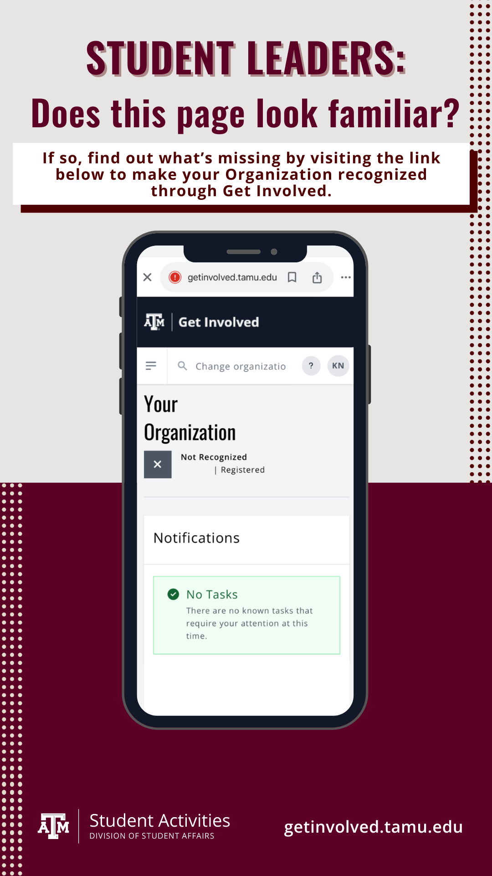

* 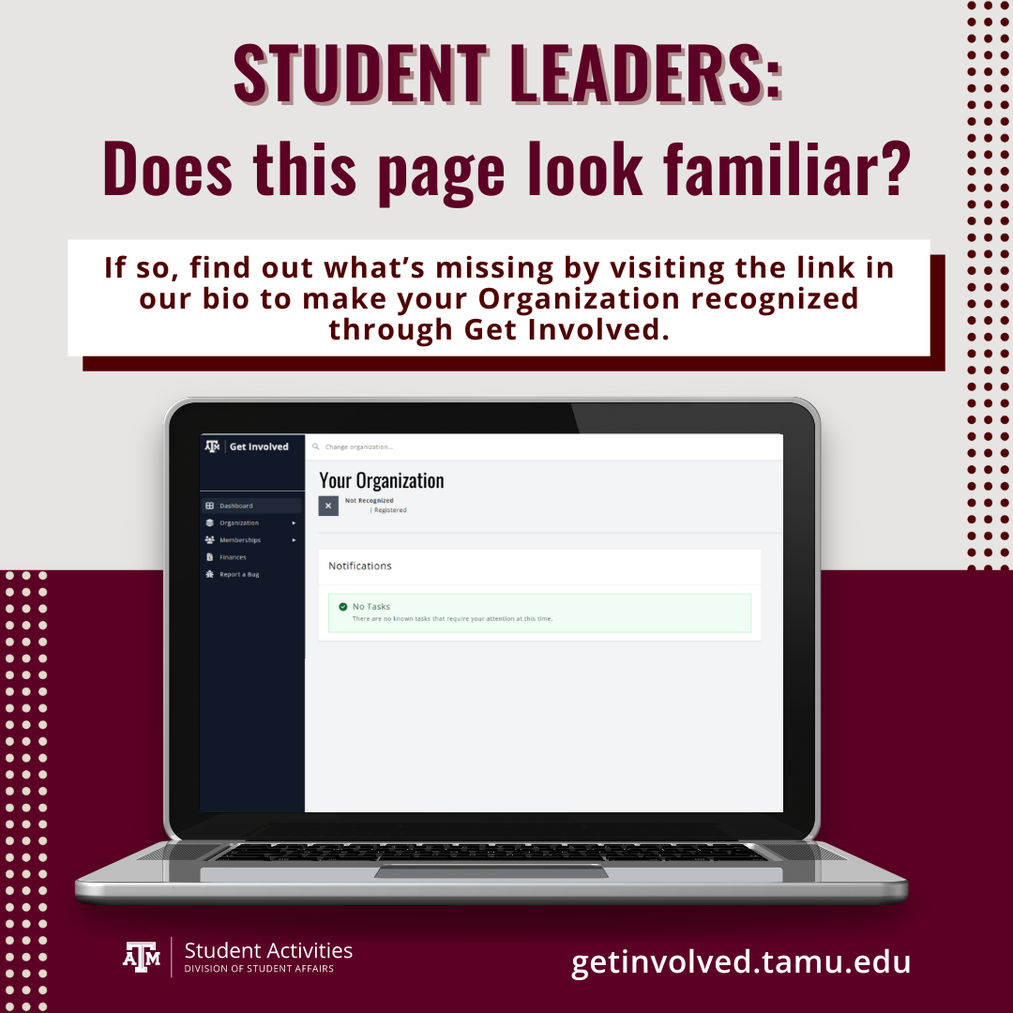

# 

# Org Events on Get Involved [Post Canva View Link](https://www.canva.com/design/DAGSnwSRp4c/2FI9hqV1EQmPl1Lh-mRQFg/edit?utm_content=DAGSnwSRp4c&utm_campaign=designshare&utm_medium=link2&utm_source=sharebutton) | [Story Canva View Link](https://www.canva.com/design/DAGSn2-ofHk/K_ecGKz7yJirIa-WpjyYeQ/edit?utm_content=DAGSn2-ofHk&utm_campaign=designshare&utm_medium=link2&utm_source=sharebutton)

Intended Audience & Direction of Post:

* Students, letting students know they can see what events are upcoming on Get Involved

Description/Goal:

* Encourage students to visit Get Involved to find events from orgs on campus
* Secondary goal: entice student leaders to post their events on Get Involved so that students can find them

Planned publishing date: Nov 6, 2024

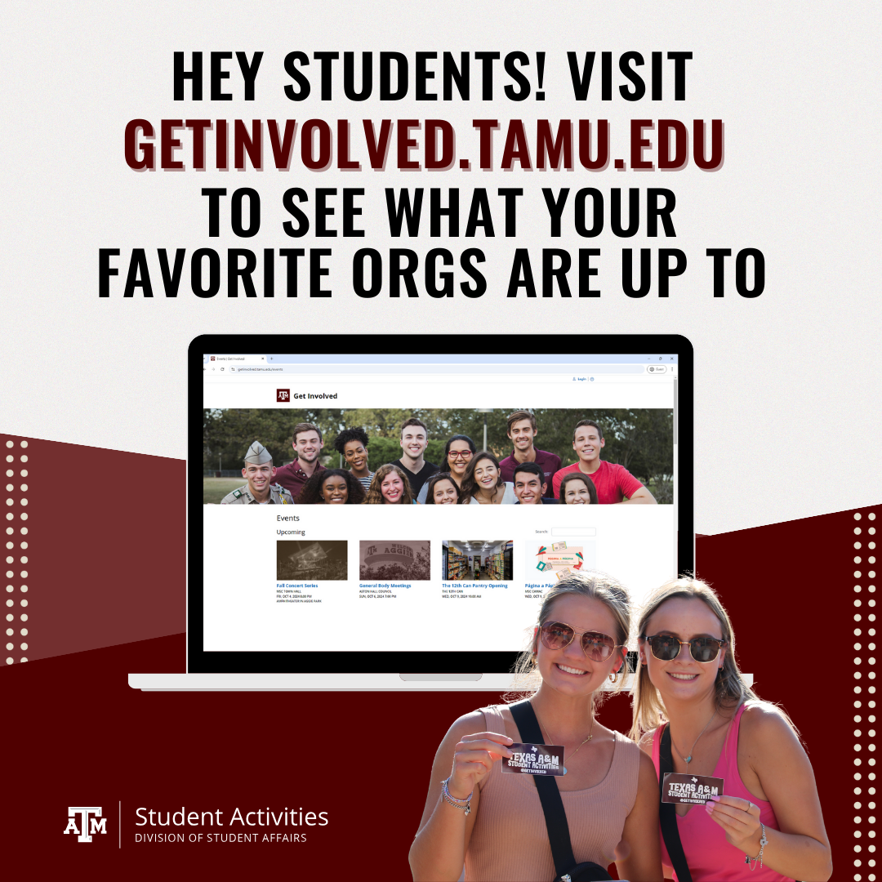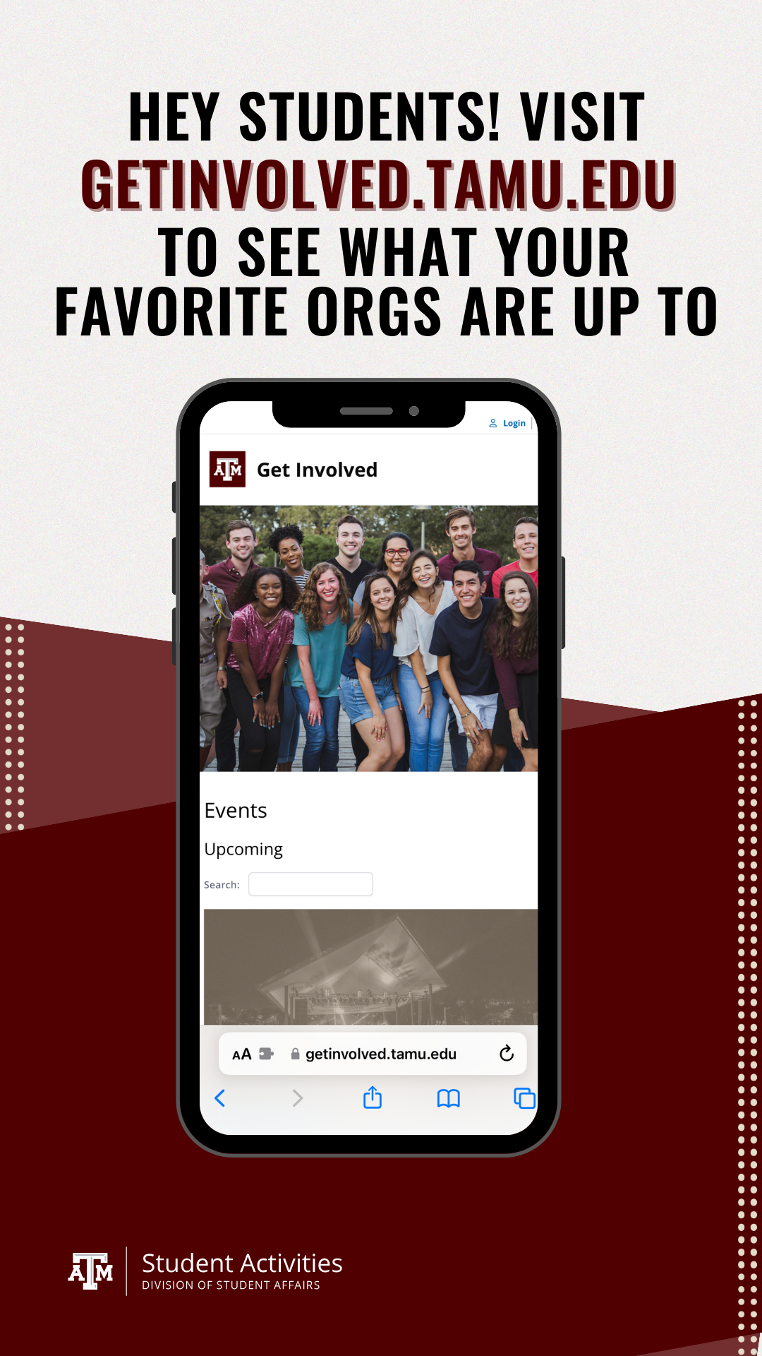

# 

# 

# Student Leader Calendar Events [Post Canva View Link](https://www.canva.com/design/DAGTF4bVOPg/XHvEE5ehmPtVbCbB-xpXKg/edit?utm_content=DAGTF4bVOPg&utm_campaign=designshare&utm_medium=link2&utm_source=sharebutton)

Intended Audience & Direction of Post:

* Students Leaders, trying to get student leaders to add their events to Get Involved so that more students can attend

Description/Goal:

* Encourage student leaders to add their events to Get Involved to increase their event attendance and knowledge of their org on campus
* Secondary goal: reemphasize to students that they can find events on Get Involved

Planned publishing date: Nov 15, 2024



 